\
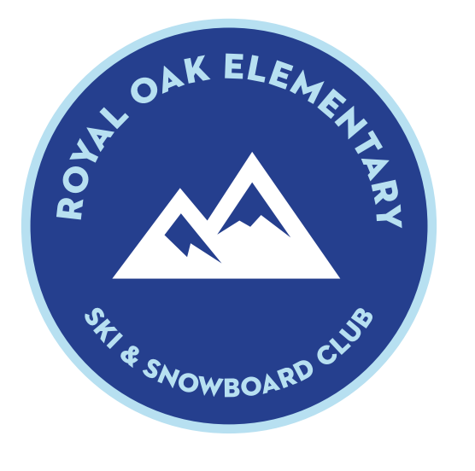

Royal Oak Elementary Schools Ski & Snowboard Club
Membership Information for 2016-2017 Season

The Oak Ridge Elementary Ski and Snowboard club was started in 2015 to get our kids and families out enjoying the fun winter weather! This year we have expanded the program to all Royal Oak Elementary schools. We are looking forward a great season on the slopes of Pine Knob Resort. Below are a few FAQs answered:

- Cost:
  - Membership card: $20 per person includes kid lessons (1 snowboard or 2 ski)
  - Student/Adult lift ticket: $20.00
  - Ski rental/Snowboard rental: $20.00
  - Helmet rental: $10.00 (required)
  - Patches: $2.50 each
  - Rentals and lift tickets paid at table with exact cash or check payable to Pine Knob Ski Resort
- When:
  - The Ski/Snowboard Club will meet every Tuesday night as soon as Pine Knob gets snow. Length of season will be driven by Pine Knob and Mother Nature but last year we skied Jan – March.
  - If you choose to go on a different weeknight, students can present their membership cards at the window after 3 pm, for the $20 student rate and adults can present their membership cards for $5 off the lift ticket price. Please note that adults cannot receive the $20 ticket price from the window. The adult discounted price of $20 is only good from the club table on Tuesday sessions. Adults are allowed 10/$5.00 off punches for themselves any session throughout the season.
- Membership cards: Student cards are available for children 7 years and older. Siblings younger are already eligible for 50% discount on tickets from the window. Membership cards will be offered at the designated club information night or payments can be sent in to school by the designated deadline. Membership cards will also be available on club nights at Pine Knob.
- Holiday break: Dec. 22nd – Jan. 2nd there will be no student club lessons or tickets. But during these dates you can present your membership card at the ticket window and receive $5 discount off the full price ticket.
- Lessons: Student membership cards include 1 snowboard lesson or 2 ski lessons. Lessons are 50 minutes and start at 5 pm, 6 pm, and 7 pm each week.
- Patches: When skiing with a student lift ticket, students are only allowed on hills based on patch level achieved. If you prefer to take your child on more advanced lifts, then you will need to purchase a full lift ticket + $5.00 discount with membership card.
- Info we need: Our club needs to notify the resort every Tuesday morning of the following:
  - Number of student and adult members attending the session
  - Number of ski rentals
  - Number of snowboard rentals
  - Number of helmets
  - We will use a method for members to RSVP every week
- Meeting area: Royal Oak Elementary Schools Ski & Snowboard club table will be open in the Pinery Cafe from 4:00-6:00 pm. This is on the upper level of the resort. Look for the Royal Oak Ski Club table. This is where you will obtain your lift ticket and rental disclaimer form for equipment which needs to be signed by a parent or guardian.
- Rental Forms: Rental forms must be filled out weekly. Payment for tickets and rentals will be received at this table. Please bring exact cash or check payable to Pine Knob Ski Resort. Ticket and rentals can be combined in 1 check - no need to bring multiple checks.
- Emergency contacts: An adult must remain at the resort during the club night. Due to the size of the resort and the age of the children, it is not feasible for us to oversee all the children safely. We will retain the contact numbers for each student in the event of an emergency. Please notify us in advance, if your child has any special medical conditions that we need to be aware of. We will keep that information on file, if needed.
- Food: There is a cafeteria at the resort. Outside carryout/drive thru food and crock pots are not allowed in the Pinery Café because it is a food establishment. Brown bag meals are permitted downstairs at Chili Joe’s.
- Equipment options:
  - Junior Has A Fit Program by Boyne Country Sports – presently now! http://www.juniorhasafit.com/default.aspx?
  - Alpine Valley Ski Swap – November 5th 9:00-4:00 pm and November 6th 11:00-3:00 pm
  - Mt. Holly Ski Swap – November 19th 8:00-3:00 pm

If you have any questions, please contact one of the Ski & Snowboard Club sponsors:
Kristen Blankenship (Sponsor) 586-291-6884 kristenblanks@hotmail.com
Trisha Donaldson (Co-Sponsor) 248 225 3985 trish1215@yahoo.com
Jason Snook (Co-Sponsor) 734-476-1304 jaypsnook@yahoo.com

